Project Planning Phase
Project Planning Template (Product Backlog, Sprint Planning, Stories, Story Points)

Date | 15 February 2025
Team ID | Not specified in project brief
Project Name | Auto Ticket Classification using Flow Designer
Maximum Marks | 5 Marks

Product Backlog, Sprint Schedule, and Estimation
The backlog below breaks the ServiceNow school IT ticket-classification solution into epics, user stories, story points, priorities, and a three-sprint implementation plan.
Sprint | Functional Requirement (Epic) | User Story Number | User Story / Task | Story Points | Priority | Team Members
Sprint-1 | Requirements & data model | USN-1 | As an IT lead, I can approve the business use case and acceptance criteria for automated ticket classification. | 2 | High | Product + IT
Sprint-1 | Requirements & data model | USN-2 | As an administrator, I can create the Project Update Set and mark it current. | 1 | High | Platform admin
Sprint-1 | Incident Workflow table | USN-3 | As an administrator, I can create the custom Incident Workflow table with auto-numbering. | 3 | High | Platform admin
Sprint-1 | Field configuration | USN-4 | As an administrator, I can add reference, choice, state, and description fields with valid values. | 5 | High | Platform admin
Sprint-2 | Flow Designer automation | USN-5 | As a system, I can classify Wi-Fi, Projector, Password/Login, and Slow/Hanging requests from keywords. | 5 | High | Flow designer
Sprint-2 | Caller communication | USN-6 | As a caller, I receive an email acknowledgement after the ticket is classified. | 2 | Medium | Flow designer
Sprint-3 | Validation & security | USN-7 | As a tester, I can verify classification, dependent choices, email delivery, and authorized access. | 3 | High | QA + IT
Sprint-3 | Deployment documentation | USN-8 | As an administrator, I can complete the update set and export the configuration to XML. | 2 | Medium | Platform admin

Project Tracker, Velocity & Burndown Chart
Sprint | Total Story Points | Duration | Sprint Start Date | Sprint End Date (Planned) | Story Points Completed (as on Planned End Date) | Sprint Release Date (Actual)
Sprint-1 | 11 | 5 working days | 17 Feb 2025 | 21 Feb 2025 | 11 | 21 Feb 2025
Sprint-2 | 7 | 5 working days | 24 Feb 2025 | 28 Feb 2025 | 7 | 28 Feb 2025
Sprint-3 | 5 | 5 working days | 03 Mar 2025 | 07 Mar 2025
Sprint-4 | 20 | 6 Days | 14 Nov 2022 | 19 Nov 2022

Velocity:
The plan contains 23 story points across three five-day sprints. Planned average velocity is 23 ÷ 3 = 7.67 story points per sprint; Sprint 1 carries the highest discovery and configuration load.
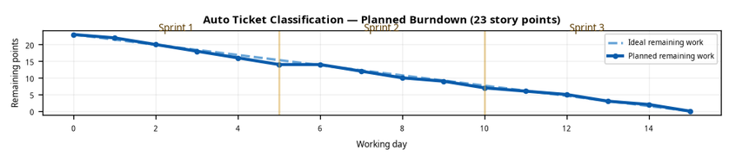

Burndown Chart:
The project burndown tracks remaining work across the three sprints: requirements and table setup, Flow Designer automation, and validation/deployment.

Source: project-specific planned burndown chart
Source: Auto Ticket Classification using Flow Designer project brief

Planning basis: project-specific backlog and sprint estimates

